# [https://avatars2.githubusercontent.com/u/4156894?v=3&s=100](http://www.calstatela.edu/centers/hipic) CIS5200 Term Project Tutorial

#### Authors: Sai Kiran Gontyala, Yoshitha Gattu, Uchechukwu Okafor, Noelle Cespedes, Oluwatofunmi Alabi

#### Instructor: [Jongwook Woo](https://www.linkedin.com/in/jongwook-woo-7081a85)

#### Date: 05/18/2019

**Lab Tutorial**

Sai Kiran Gontyala ([sgontya@calstatela.edu](mailto:sgontya@calstatela.edu))

Yoshitha Gattu ([ygattu@calstatela.edu](mailto:ygattu@calstatela.edu))

Uchechukwu Okafor ([uokafor3@calstatela.edu](mailto:uokafor3@calstatela.edu))

Noelle Cespedes ([ncesped3@calstatela.edu](mailto:ncesped3@calstatela.edu))

Oluwatofunmi Alabi (oalabi@calstatela.edu)

05/18/2019

**Data Analysis using Spark (PUBG death rate)**

**Objectives**

In this hands-on lab, you will learn how to:

* Uploaded the dataset for PUBG death rate
* Data cleaning using Hive
* HiveQL commands to perform the analysis
* Visualization in Power BI, Tableau and MS Excel

**Platform Spec**

* Oracle Big Data Compute Edition
* CPU Speed: 2.195 GHz
* # of CPU cores: 4 cores, 1 Socket
* # of nodes: 5 nodes
* Total Memory Size: 8GB

**INTRODUCTION**

Video games are a rich area for data extraction due to its digital nature. PUBG is a popular game PlayerUnknown's Battlegrounds. This dataset provide over 720,000 competitive matches. PUBG is a first/third-person shooter battle royale style game that matches over 90 players on a large island where teams and players fight to the death until one remains. This project will demonstrate the usage of Hadoop, MapReduce, and Hive on big data. We will apply the knowledge learned during the lecture, extensive researches and development of HiveQL in order to generate data and visualize it on Power BI, Tableau and 3D maps.

**Step 1: Data Upload to server**

**Server IP:** **129.150.123.30**

* Download the dataset from the url:

<https://www.kaggle.com/skihikingkevin/pubg-match-deaths>

* Use the software WinSCP to upload the dataset agg_0.csv and kill_0 of size 2GB each [8GB unzipped] from local system to oracle server.

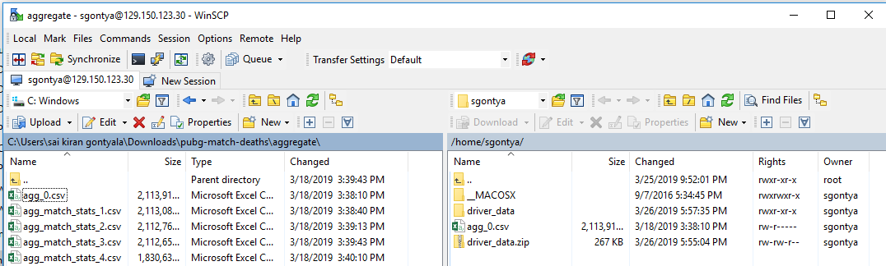

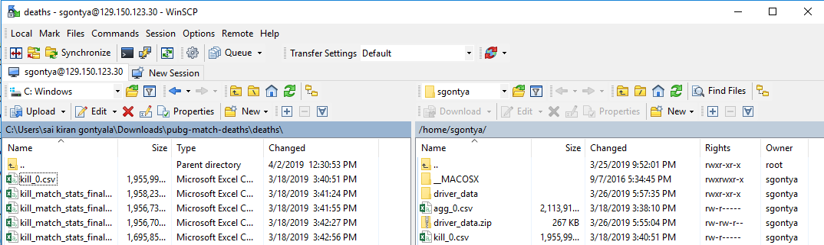

* Use the command **ls** to list the files as a csv format.

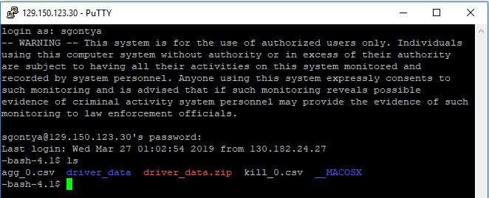

**Step 2: Uploading data to HDFS**

* Create folders using **mkdir** command, Change the permission for the file using below command to get full access to the file.

**hdfs dfs -mkdir Group4/agg_0**

**hdfs dfs -chmod -R o+w Group4/agg_0**

**hdfs dfs -mkdir Group4/kill_0**

**hdfs dfs -chmod -R o+w Group4/kill_0**

* Use **hdfs dfs -put** command to upload the data from the Linux server to HDFS

**hdfs dfs -put agg_0.csv**

**hdfs dfs -put kill_0.csv**

* Use **hdfs dfs -mv** to move file from hdfs parent folder to created directory.

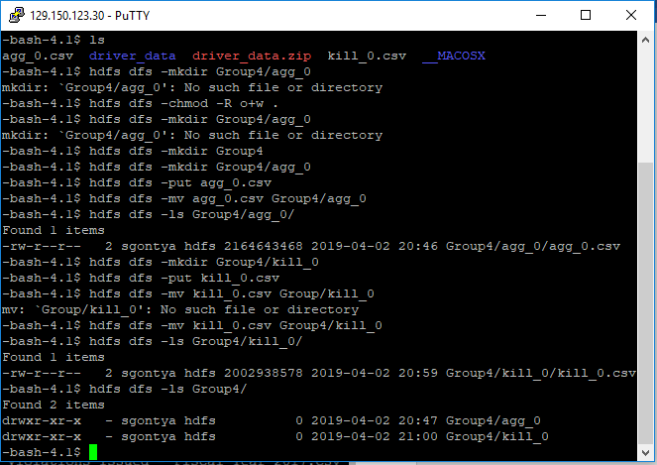

**Step 3: Connecting server to HIVE**

* Use the command **beeline** to connect with to Hive

**!connect jdbc:hive2://cis5200spr19-bdcsce-2.compute-608214094.oraclecloud.internal:2181,cis5200spr19-bdcsce-3.compute-608214094.oraclecloud.internal:2181,cis5200spr19-bdcsce-4.compute-608214094.oraclecloud.internal:2181/;serviceDiscoveryMode=zooKeeper;zooKeeperNamespace=hiveserver2?tez.queue.name=interactive bdcsce_admin**

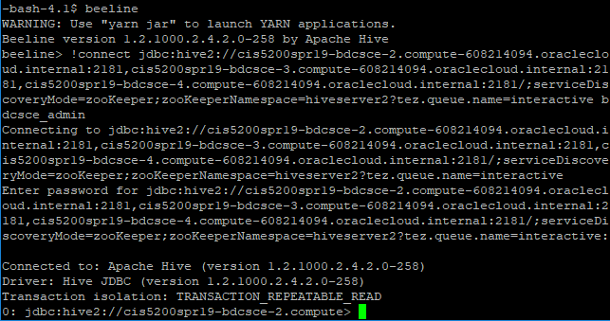

**Step 4: Creating Database**

* Use **create database** to create a database named group3.

**create database group4;**

* To view the newly created database use.

**Show databases;**

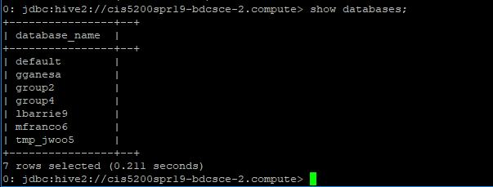

**Step 5: Creating Tables in Database**

* To **Create External table,** use below command,

CREATE EXTERNAL TABLE IF NOT EXISTS aggregate_0

(date_time BIGINT,game_size INT,match_id STRING,match_mode STRING,party_size INT,player_assists INT,player_dbno INT,player_dist_ride FLOAT,player_dist_walk FLOAT,player_dmg INT,player_kills INT,player_name STRING,player_survive_time FLOAT,team_id INT,team_placement INT)

ROW FORMAT DELIMITED FIELDS TERMINATED BY ','

STORED AS TEXTFILE LOCATION '/user/sgontya/Group4/agg_0'

TBLPROPERTIES ('skip.header.line.count'='1');

CREATE EXTERNAL TABLE IF NOT EXISTS kills_0

(killed_by STRING,killer_name STRING,killer_placement INT,killer_position_x FLOAT,killer_position_y FLOAT,map_location STRING,match_id STRING,time INT,victim_name STRING,victim_placement INT,victim_position_x FLOAT,victim_position_y FLOAT)

ROW FORMAT DELIMITED FIELDS TERMINATED BY ','

STORED AS TEXTFILE LOCATION '/user/sgontya/Group4/kill_0'

TBLPROPERTIES ('skip.header.line.count'='1');

Step 6: Dataset cleaning in Hive

As the PUBG death rate dataset has more number of uwanted data like blank cells and irrelevent data it needs to be filter out and saved as New file Cln_agg_0, Cln_kills_0 in the path /user/sgontya/Group4/

* Use the below command to clean the dataset,

CREATE TABLE cln_agg_0

ROW FORMAT DELIMITED FIELDS TERMINATED BY ','

STORED AS TEXTFILE LOCATION '/user/sgontya/Group4/cln_agg_0'

AS

SELECT

date_time, game_size, match_id, match_mode, party_size, player_assists, player_dbno, player_dist_ride, player_dist_walk, player_dmg, player_kills, player_name, player_survive_time, team_id, team_placement from aggregate_0

where

player_name != ' '

;

CREATE TABLE cln_kills_0

ROW FORMAT DELIMITED FIELDS TERMINATED BY ','

STORED AS TEXTFILE LOCATION '/user/sgontya/Group4/cln_kills_0'

AS

SELECT

killed_by, killer_name, killer_placement, killer_position_x, killer_position_y, map_location, match_id, time, victim_name, victim_placement, victim_position_x, victim_position_y from kills_0

where

killer_name != ' ' OR killer_placement != ' ' OR killer_position_x != ' ' OR killer_position_y != ' ' OR map_location != ' ' OR victim_placement != ' ' LIMIT 10;

;

* Use the command to view all the tables in the database,

**Show tables;**

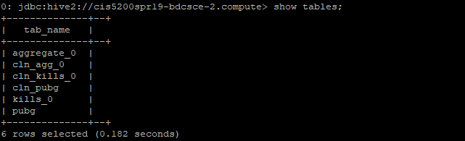

Step 7: Creating Hive Queries to Analyze Data

The following Hive queries analyses the PUBG death rates**.**

1. **Query to analyse the Total number of players in the given dataset.**

CREATE TABLE **players_count**

ROW FORMAT DELIMITED FIELDS TERMINATED BY ','

STORED AS TEXTFILE LOCATION '/user/sgontya/Group4/players_count'

AS

select count(player_name) as number_of_players from cln_agg_0;

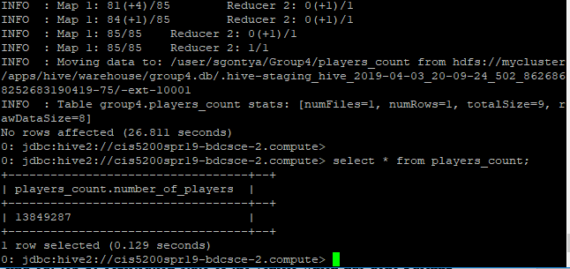

1. **Query to find out map location people are interested in:**

CREATE TABLE **map_location**

ROW FORMAT DELIMITED FIELDS TERMINATED BY ','

STORED AS TEXTFILE LOCATION '/user/sgontya/Group4/map_location'

AS

SELECT map_location, COUNT(map_location)

FROM cln_kills_0

WHERE map_location IN ('ERANGEL' , 'MIRAMAR')

GROUP BY map_location

HAVING COUNT(map_location) > 1;

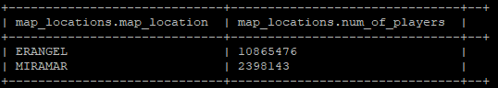

1. **Query to find out party size people are interested in:**

CREATE TABLE **party_sizes**

ROW FORMAT DELIMITED FIELDS TERMINATED BY ','

STORED AS TEXTFILE LOCATION '/user/sgontya/Group4/party_sizes'

AS

SELECT party_size, COUNT(party_size) AS num_of_players

FROM cln_agg_0

GROUP BY party_size

HAVING COUNT(party_size) > 0;

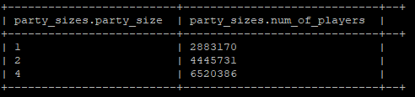

1. **Query to find out number of kills by a player.**

CREATE TABLE **player_kills**

ROW FORMAT DELIMITED FIELDS TERMINATED BY ','

STORED AS TEXTFILE LOCATION '/user/sgontya/Group4/player_kills/'

AS

SELECT player_kills, COUNT(player_kills)

FROM cln_agg_0

GROUP BY player_kills

HAVING COUNT(player_kills) > 1

ORDER BY player_kills desc LIMIT 10;

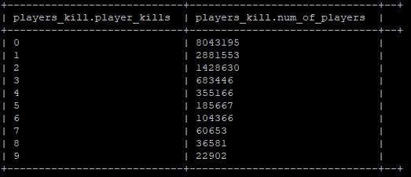

1. **Query to find out assist points scored by the players.**

CREATE TABLE **player_assists**

ROW FORMAT DELIMITED FIELDS TERMINATED BY ','

STORED AS TEXTFILE LOCATION '/user/sgontya/Group4/player_assists/'

AS

SELECT player_assists, COUNT(player_assists)

FROM cln_agg_0

GROUP BY player_assists

HAVING COUNT(player_assists) > 1

ORDER BY player_assists asc;

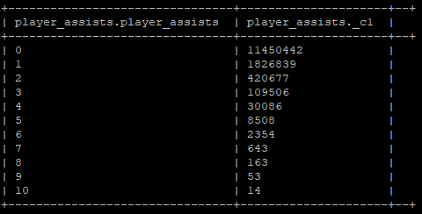

1. **Query to find out survival time of the players**

CREATE TABLE **survival_time**

ROW FORMAT DELIMITED FIELDS TERMINATED BY ','

STORED AS TEXTFILE LOCATION '/user/sgontya/Group4/survival_time/'

AS

SELECT time, COUNT(time)

FROM cln_kills_0

GROUP BY time

HAVING COUNT(time) > 1;

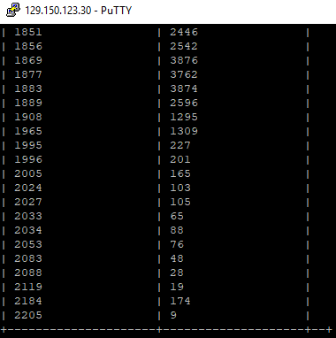

1. **Query to find out Highest distance covered by teams.**

CREATE TABLE **dist_covered_team**

ROW FORMAT DELIMITED FIELDS TERMINATED BY ','

STORED AS TEXTFILE LOCATION '/user/sgontya/dist_covered_team'

AS

SELECT team_id, (player_dist_ride + player_dist_walk) AS total_dist

FROM cln_agg_0

ORDER BY total_dist DESC

LIMIT 10;

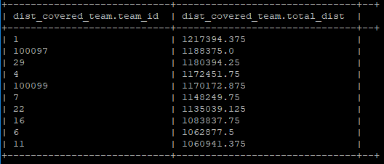

1. **Query to find out COORDINATES WITH HIGHEST NUMBER OF CASUALTIES (killer's position)**

CREATE TABLE **killers_coordinates**

ROW FORMAT DELIMITED FIELDS TERMINATED BY ','

STORED AS TEXTFILE LOCATION '/user/sgontya/killers_coordinates'

AS

SELECT killer_position_x, killer_position_y, COUNT(victim_name) as casualties

FROM cln_kills_0

WHERE killer_position_x != 'NULL' OR killer_position_x != '0.0'

GROUP BY killer_position_x, killer_position_y

ORDER BY casualties desc

LIMIT 10;

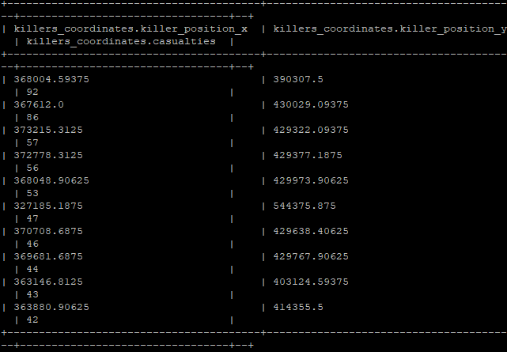

1. **Query to find out COORDINATES WITH HIGHEST NUMBER OF CASUALTIES(Victim's position)**

CREATE TABLE **victim_coordinates**

ROW FORMAT DELIMITED FIELDS TERMINATED BY ','

STORED AS TEXTFILE LOCATION '/user/sgontya/Group4/victim_coordinates'

AS

SELECT victim_position_x, victim_position_y, COUNT(victim_name) as casualties

FROM cln_kills_0

WHERE victim_position_x != '0.0'

GROUP BY victim_position_x, victim_position_y

ORDER BY casualties desc

LIMIT 10;

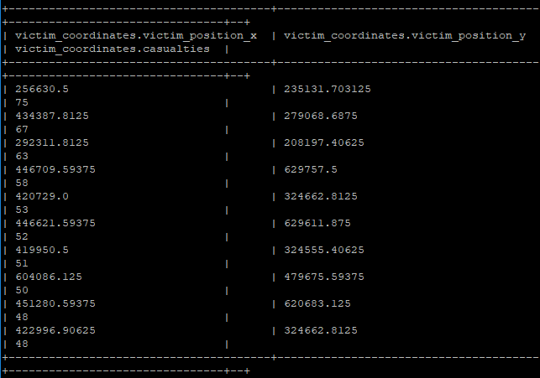

10. **Query to find out top 10 DISTANCE COVERED ON FOOT players.**

CREATE TABLE **distance_on_foot**

ROW FORMAT DELIMITED FIELDS TERMINATED BY ','

STORED AS TEXTFILE LOCATION '/user/sgontya/Group4/distance_on_foot'

AS

SELECT player_name, player_dist_walk

FROM cln_agg_0

ORDER BY player_dist_walk DESC

LIMIT 10;

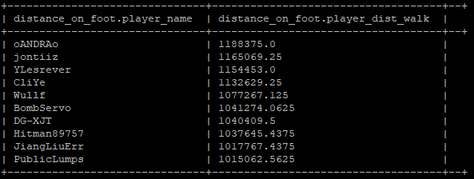

11. **Query to find out HIGHEST SURVIVAL TIME**

CREATE TABLE **highest_survival_time**

ROW FORMAT DELIMITED FIELDS TERMINATED BY ','

STORED AS TEXTFILE LOCATION '/user/sgontya/Group4/highest_survival_time'

AS

SELECT team_id, count(player_survive_time) as team_survive_time

from cln_agg_0

WHERE party_size = 1

GROUP

BY team_id

ORDER BY team_survive_time desc

LIMIT 10;

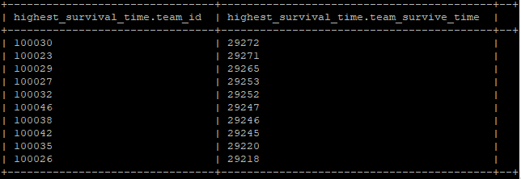

12. **Query to find out HIGHEST KILLS-SINGLE PLAYER**

CREATE TABLE **highest_single_kills**

ROW FORMAT DELIMITED FIELDS TERMINATED BY ','

STORED AS TEXTFILE LOCATION '/user/sgontya/Group4/highest_single_kills'

AS

SELECT team_id, party_size, count(player_kills) as team_kills

FROM cln_agg_0

WHERE party_size = 1

GROUP BY team_id, party_size

ORDER BY team_kills DESC

LIMIT 10;

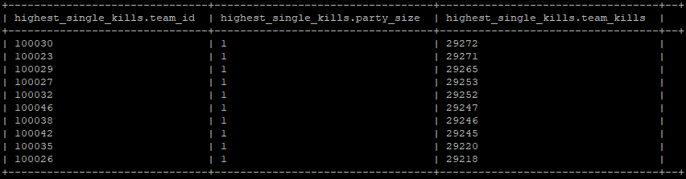

13. **Query to find out REASONS FOR DEATH OF A PLAYER**

CREATE TABLE **Reason_for_death**

ROW FORMAT DELIMITED FIELDS TERMINATED BY ','

STORED AS TEXTFILE LOCATION '/user/sgontya/Group4/Reason_for_death'

AS

SELECT killed_by, COUNT(killed_by) AS Num_of_kills

FROM cln_kills_0

GROUP BY killed_by

HAVING COUNT(killed_by) > 1

ORDER BY Num_of_kills DESC;

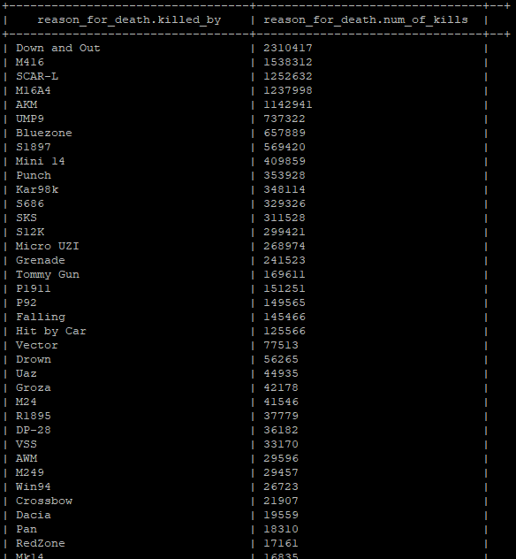

**Step 8: Exporting data from HIVE**

Use the below command to export the table from HDFS to Linux server,

hdfs dfs **-get** Group4/killed_by_weapon /000000_0



Open Windows power shell. Use the command showed below to export the data to the base machine in the form of .csv format

**pscp** -pw sgontya sgontya@129.150.123.30:/home/sgontya/000000_0 killed_by_weapon.csv

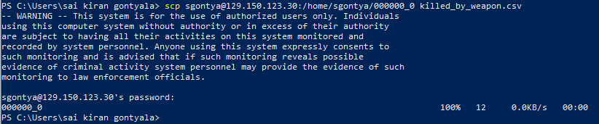

**NOTE:** Replace **killed_by_weapon** with other file names. And to download csv files of other analyzed tables, first remove 000000_0 in hdfs using **hdfs dfs -rm 000000_0** command. Then get respective 000000_0 of required table and download it to local file using **pscp.**

Step 9: Data Visualization using PowerBI, Tableau and Excel

1. Open your PowerBI and upload the **map_location.csv** file.

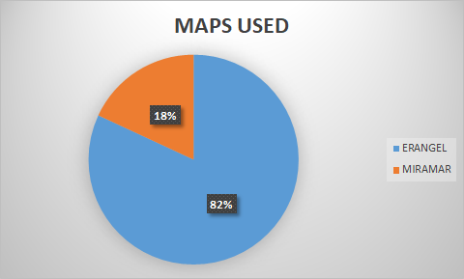

The pie chart shows the map locations players are interested in.

1. Open your Tableau to connect your server. You need to select **Text File** to open the file **party_size.csv**

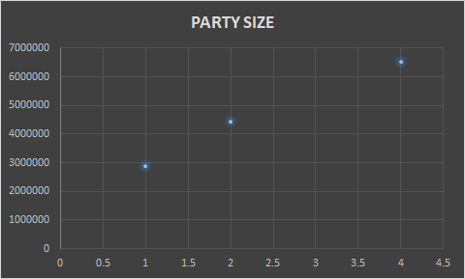

The above chart shows the party size players are interested in.

1. Open your PowerBI and upload the **players_kill.csv** file.

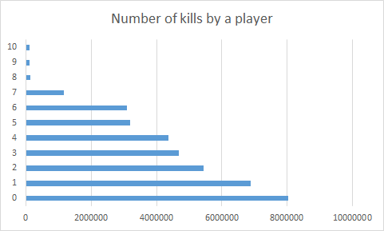

The above graph shows the number of kills by a player.

1. Open your PowerBI and upload the **player_assists.csv** file.

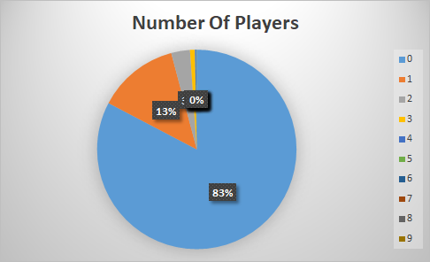

The pie chart shows the assist points scored by the players.

1. Open your PowerBI and upload the **survival_time.csv** file.

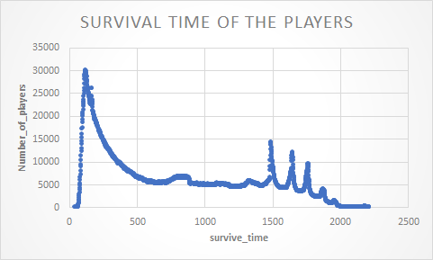

The above graph shows the survival time by different players.

1. Open your PowerBI and upload the dist_covered_team**.csv**.

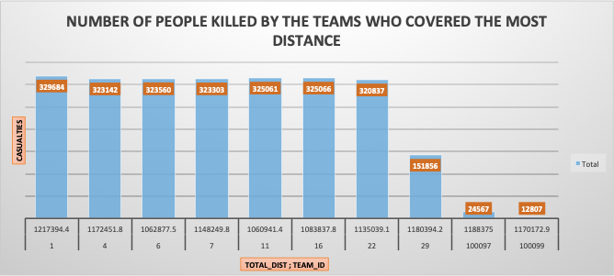

The above graph shows the highest distance covered by teams.

1. Open your PowerBI and upload the **killers_coordinates.csv.**

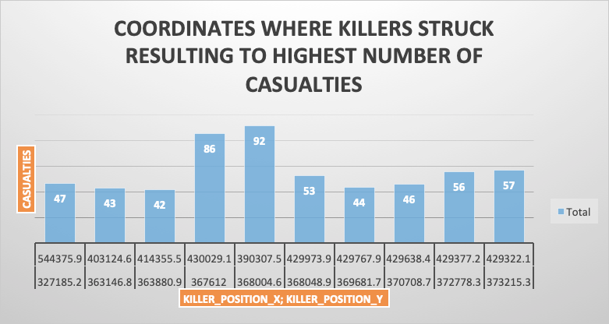

The above graph shows the coordinates where killers struck resulting to highest number of casualities.

1. Open your PowerBI and upload the **victim_coordinates.csv.**

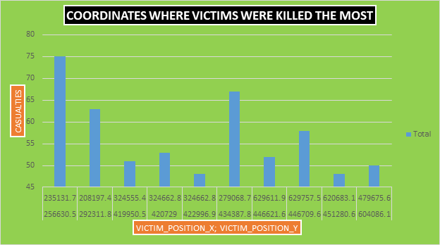

This bar chart shows the coordinates where victims were killed the most.

1. Open your PowerBI and upload the **distance_on_foot.csv.**

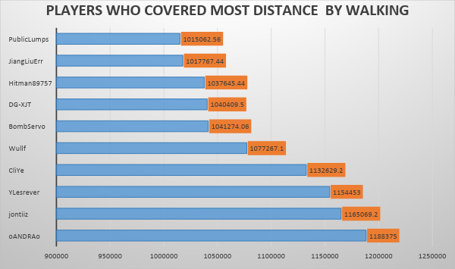

This chart shows players who covered most distance by walking.

1. Open your PowerBI and upload the **highest_survivsl_time.csv.**

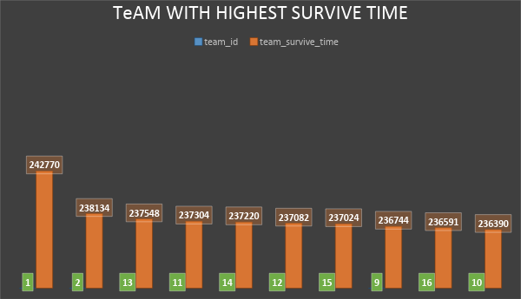

This bar chart shows the team with highest survival time.

1. Open your PowerBI and upload the **highest_single_kills.csv**

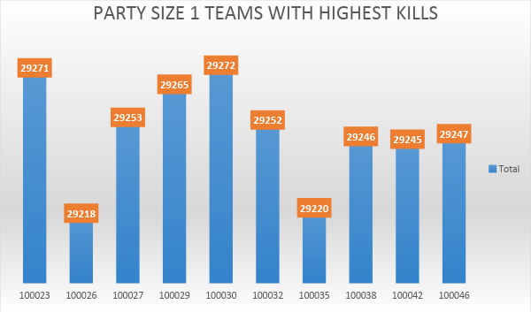

The above chart shows the party size 1 teams with highest kills.

1. Open your PowerBI and upload the **reason_for_death.csv**

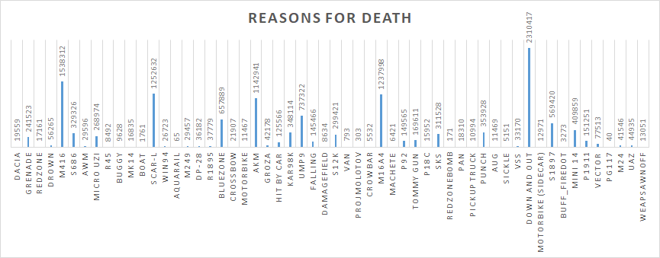

The above bar chart shows the reasons for death of different players.

References

**https://github.com/sgontya/hiveanalysisonpubgdeathrate**

**https://www.kaggle.com/skihikingkevin/pubg-match-deaths**

[**https://www.pocket-lint.com/games/news/144028-what-is-pubg-mobile-and-why-is-everyone-talking-about-playerunknown-s-battlegrounds**](https://www.pocket-lint.com/games/news/144028-what-is-pubg-mobile-and-why-is-everyone-talking-about-playerunknown-s-battlegrounds)

[**https://store.steampowered.com/app/578080/PLAYERUNKNOWNS_BATTLEGROUNDS/**](https://store.steampowered.com/app/578080/PLAYERUNKNOWNS_BATTLEGROUNDS/)